SOFTWARE ENGINEERING PROCESS MODEL

Process models define a distinct set of activities , actions, tasks, milestones, and work

products that are required to engineer high-quality software. They provide a useful road-

map for software engineering work.

In this application I am using the WATERFALL MODEL for software engineering

process. The WATERFALL MODEL, sometimes called the CLASSIC LIFE CYCLE,

suggests a systematic, sequential approach to software development that begins with

Customer Specification of requirements and progresses through Planning, Modeling,

Construction, and Deployment, culminating in on-going support of the complete software.

Planning
estimating
scheduling
tracking

Communication
project initiation
req,, gathering

Modeling
analysis
design

Construction
code
test

Deployment
delivery
support
feedback
Waterfall model stages

WATERFALL MODEL
CONTENTS

1. Organization Profile ………………………………………………. 1

2. Project Introduction ……………………………………………… 4

  - ABSTRACT …………………….…………….......................................... 5
  - introction…………………………………………............................... 6

3. System Analysis …………………………………………………............9

3.1. literature survey ……………………………………………….10
  - existingsystem………………………………………………………19
  - Proposed System……………………………………………….........20
  - purpose ………………………………………………………………....21

4. Software Requirement Specification ……………………….22

  - specipication PRINCIPLES.………………………………………….23
  - FEASIBILITY STUDY………… …………………………………...........24
  - SYSTEM REQUIREMENTS………….. ………………………………....26

5. SOFTWARE Design..………………………………………………….........27

5.1. Introduction …………………………………………………….......28
5.2 SYSTEM ARCHITECTURE………………………………………………29
5.3.DATA FLOW DIAGRAMS……………………………………………….30
5.4.UML DIAGRAMS…………………………………………………………33

6. Coding and Implementation ……………...………………….........44

6.1. ModuleS OF THE PROJECTS…………………………………….........45
6.2. Features OF SOFTWARE……………………………………………..47

7. SCREENs……. ……………………………………….……………………….50

8. TESTING……………… …………………………………………………….....60

9. CONCLUSION……………. ………………………………………………….63

10. SCOPE FOR FUTURE ENHANCEMENTS ………………………………65

11. BIBLIOGRAPHY …………………………………………………………….67

- ORGANISATION PROFILE

At TECHSOL Technologies, We go beyond providing software solutions. We work with our client’s technologies and business changes that shape their competitive advantages.
Founded in 2000,TECHSOL Technologies (P) Ltd. is a software and service provider that helps organizations deploy, manage, and support their business-critical software more effectively. Utilizing a combination of proprietary software, services and specialized expertise, TECHSOL Technologies (P) Ltd. helps mid-to-large enterprises, software companies and IT service providers improve consistency, speed, and transparency with service delivery at lower costs. TECHSOL Technologies (P) Ltd. helps companies avoid many of the delays, costs and risks associated with the distribution and support of software on desktops, servers and remote devices. Our automated solutions include rapid, touch-free deployments, ongoing software upgrades, fixes and security patches, technology asset inventory and tracking, software license optimization, application self-healing and policy management. At TECHSOL Technologies, we go beyond providing software solutions. We work with our clients’ technologies and business processes that shape there competitive advantages.
About The People
As a team we have the prowess to have a clear vision and realize it too. As a statistical evaluation, the team has more than 40,000 hours of expertise in providing real-time solutions in the fields of Embedded Systems, Control systems, Micro-Controllers, c Based Interfacing, Programmable Logic Controller, VLSI Design And Implementation, Networking With C, ++, java, client Server Technologies in Java,(J2EE\J2ME\J2SE\EJB),VB & VC++, Oracle and operating system concepts with LINUX.

Quality Objectives
To enhance the company's ability to consistently meet our customer's needs, by improving organizational and team effectiveness.
To realize our quality policy, daily improvements will be coupled with individual and team innovations in the following areas:
- Continuous improvement and learning: Improvement and learning are regular part of daily work so that each employee seeks to eliminate problems at the source and identifies opportunities for improvement
- Customer Driven Quality: Quality is judged by the customer. The quality process must lead to services that contribute value and lead to customer delight
- Timely support to customer
We meet customer expectations by:
- Understanding the needs of customers
- Anticipating and working towards the future needs of customers
- Constantly improving and preventing errors from occurring
- Attracting, training and retaining qualified staff
Our Vision
“Dreaming a vision is possible and realizing it is our goal”.
Our Mission
We have achieved this by creating and perfecting processes that are in par with the global standards and we deliver high quality, high value services, reliable and cost effective IT products to clients around the world.
Clientele
- Aray InfoTech
- Inquirre consultancy (U.S.A)

- PROJECT INTRODUCTION

2.1 ABSTRACT

Self-propagating codes, called worms, such as Code Red, Nimda, and Slammer, have drawn significant attention due to their enormously adverse impact on the Internet. Thus, there is great interest in the research community in modeling the spread of worms and in providing adequate defense mechanisms against them. In this paper, we present a (stochastic) branching process model for characterizing the propagation of Internet worms. The model is developed for uniform scanning worms and then extended to preference scanning worms. This model leads to the development of an automatic worm containment strategy that prevents the spread of a worm beyond its early stage. Specifically, for uniform scanning worms, we are able to determine whether the worm spread will eventually stop. We then extend our results to contain uniform scanning worms. Our automatic worm containment schemes effectively contain both uniform scanning worms and local preference scanning worms, and it is validated through simulations and real trace data to be non intrusive.
2.2 Introduction

The Internet has become critically important to the financial viability of the national and the global economy. Meanwhile, we are witnessing an upsurge in the incidents of malicious code in the form of computer viruses and worms. One class of such malicious code, known as random scanning worms, spreads itself without human intervention by using a scanning strategy to find vulnerable hosts to infect. Code Red, SQL Slammer, and Sasser are some of the more famous examples of worms that have caused considerable damage. Network worms have the potential to infect many vulnerable hosts on the Internet before human countermeasures take place. The aggressive scanning traffic generated by the infected hosts has caused network congestion, equipment failure, and blocking of physical facilities such as subway stations, 911 call centers, etc. As a representative example, consider the Code RedwormVersion 2 that exploited buffer overflow vulnerability in the Microsoft IISWebservers. It was released on19 July 2001 Andover a period of less than 14 hours infected more than 359,000 machines. The cost of the epidemic, including subsequent strains of Code Red, has been estimated by Computer Economics to be $2.6 billion.

The goal of our research is to provide a model for the propagation of random scanning worms and the corresponding development of automatic containment mechanisms that prevent the spread of worms beyond their early stages. This containment scheme is then extended to protect an enterprise network from a preference scanning worm. A host infected with random scanning worms finds and infects other vulnerable hosts by scanning a list of randomly generated IP addresses. Worms using other strategies to find vulnerable hosts to infect are not within the scope of this work. Some examples of nonrandom-scanning worms are e-mail worms, peer-to-peer worms, and worms that search the local host for addresses to scan.

Most models of Internet-scale worm propagation are based on deterministic epidemic models. They are acceptable for modeling worm propagation when the number of infected hosts is large. However, it is generally accepted that they are inadequate to model the early phase of worm propagation accurately because the number of infected hosts early on is very small. The reason is that epidemic models capture only expected or means behavior while not being able to capture the variability around this mean, which could be especially dramatic during the early phase of worm propagation. Although stochastic epidemic models can be used to model this early phase, they are generally too complex to provide useful analytical solutions.

In this paper, we propose a stochastic branching process model for the early phase ofwormpropagation.1Weconsider the generation-wise evolution of worms, with the hosts that are infected at the beginning of the propagation forming generation zero. The hosts that are directly infected by hosts in generation n are said to belong to generation n þ 1. Our model captures the worm spreading dynamics for worms of arbitrary scanning rate, including stealth worms that may turn themselves off at times. We show that it is the total number of scans that an infected host attempts, and not the more restrictive scanning rate, which determines whether worms can spread. Moreover, we can probabilistically bound the total number of infected hosts. These insights lead us to develop an automatic worm containment strategy. The main idea is to limit the total number of distinct IP addresses contacted (denote the limit as MC) per host over a period we call the containment cycle, which is of the order of weeks or months. We show that the value of MC does not need to be as carefully tuned as in the traditional rate control mechanisms. Further, we show that this scheme will have only marginal impact on the normal operation of the networks. Our scheme is fundamentally different from rate limiting schemes because we are not bounding instantaneous scanning rates. Preference scanning worms are a common class of worms but have received significantly less attention from the research community. Unlike uniform scanning worms, this type of worm prefers to scan random IP addresses in the local network to the overall Internet. We show that a direct application of the containment strategy for uniform scanning worms to the case of preference scanning worms makes the system too restrictive in terms of the number of allowable scans from a host. We therefore propose a local worm containment system based on restricting a host’s total number of scans to local unused IP addresses (denoted as N). We then use a stochastic branching process model to come up with a bound on the value of N to ensure that the worm spread is stopped.

The main contributions of the paper are summarized as follows: We provide a means to accurately model the early phase of propagation of uniform scanning worms. We also provide an equation that lets a system designer probabilistically bound the total number of infected hosts in a worm epidemic. The parameter that controls the spread is the number of allowable scans for any host. The insight from our model provides us with a mechanism for containing both fast-scanning worms and slow-scanning worms without knowing the worm signature in advance or needing to detect whether a host is infected. This scheme is non-intrusive in terms of its impact on legitimate traffic. Our model and containment scheme is validated through analysis, simulation, and real traffic statistics.
The rest of the paper is organized as follows: In Section 2, we review relevant research on network worms. In Section 3, we present our branching process model with corresponding analytical results on the spread of the infection. In Sections 4 and 5, we describe an automatic worm containment scheme for random scanning worms and adaptation to the case of local preference scanning worms. In Section 6, we provide
numerical results that validate our model and confirm the effectiveness of our containment scheme.

3. SYSTEM ANALYSIS
3.1 LITERATURE SURVEY

- The goal of our project is to provide a model for the propagation of random scanning worms and the corresponding development of automatic containment mechanisms that prevent the spread of worms beyond their early stages.
- This containment scheme is then extended to protect an enterprise network from a preference scanning worm.
- A host infected with random scanning worms finds and infects other vulnerable hosts by scanning a list of randomly generated IP addresses.
- Worms using other strategies to find vulnerable hosts to infect are not within the scope of this work.
- Some examples of non random-scanning worms are e-mail worms, peer-to-peer worms, and worms that search the local host for addresses to scan.

In this project, we adopt a stochastic branching process model for the early phase of worm propagation. We consider the generation-wise evolution of worms, with the hosts that are infected at the beginning of the propagation forming generation zero. The hosts that are directly infected by hosts in generation n are said to belong to generation n+1. Our model captures the worm spreading dynamics for worms of arbitrary scanning rate, including stealth worms that may turn themselves off at times.

worms:
Definition of computer worm:
A computer worm is a self-replicating computer program. It uses a network to send copies of itself to other nodes (computers on the network) and it may do so without any user intervention. Unlike a virus, it does not need to attach itself to an existing program. Worms almost always cause harm to the network, if only by consuming bandwidth, whereas viruses almost always corrupt or modify files on a targeted computer.
Worms are hated because of:
    - Bandwidth consumption
    - Might crash computers they infect
    - Infected computers may be used for other attacks such as DDoS, Phishing attacks etc
Types of computer worms :
- Host computer worms - Host computer worms are entirely contained in the computer they run on and use network connections only to copy themselves to other computers. Host computer worms where he original terminates itself after launching a copy on another host (so there is only one copy of the worm running somewhere on the network at a given moment) are also called "rabbits".
- network worms- Network worms consist of multiple parts (called "segments"), each running on different machines (and possibly performing different actions) and using the network for several communication purposes. Propagating a segment from one machine to another is only one of those purposes. Network worms that have one main segment, which coordinates the work of the other segments are sometimes called "octopuses."
History:
The first ever programme that could be called a worm, as per definition, was developed for the assistance of air traffic controllers by Bob Thomas in 1971. This worm" programme would notify air traffic controllers when the controls of a plane moved from one computer to another. In fact, this worm named "creeper" would travel from one computer screen to the other on the network showing the message, "I'm reeper! Catch me if you can!" The difference from most worms was that this creeper did not reproduce itself. Even later, although the idea of developing worms slowly faded away, a few people did try to experiment with these. These included John Shock and Jon Hepps of Xerox's Palo Alto Research Center, who in the early 1980s began working on worm programmers. This was also the first time that this type of programmer was called a worm.
Both of them developed a total of 5 worms, each specially designed to perform a particular function. They were programmed to do certain tasks around the network. The simplest of these worms was a "town crier" worm. Its job was only to post announcements on all the computers of the network. Then there were the more complicated worms, like the one, which would remain completely dormant during the day and would activate only in the night. Once all the employees had left for the day, this worm would harness the extra computing power of the idle computers to do tasks which required more computing power. In the morning, before the arrival of the employees it would save all the work done during the night and become dormant till the next evening.
Some World Famous Worms
The Internet Worm – 1988: On November the 22nd, 1988, Robert Morris, a Cornell University science graduate accidentally released his worm on a very large network in the area. This network was named Arpanet, which later went on to become the Internet. The worm managed to infect approximately three thousand computers during eight hours of activity. The Internet worm as it came to be known, disabled all those machines by making copies of itself and thus clogging them. Apart from clogging all the security loopholes, many machines had to be completely taken off the network till all copies of the worm could be totally removed.
The SPAN network worm – 1989: On the 16th of October 1989, a worm named WANK infected many VAX and VMS computers on the SPAN network. This worm, if it found that it had system privileges, would then change the system announcement message to "Worms against Nuclear Killers!" The message was then graphically displayed as the first letters of each word and the last three letters of the last word.
The Christmas tree Worm – 1987:The Christmas tree worm, which was a combination of a Trojan Horse and a chain letter. This was a mainframe worm and managed to paralyze the IBM network on Christmas day 1987. The worm was written in a language called Exec. It asked the user to type the word "Christmas" on the screen. Then it drew a Christmas tree and sent itself to all the names of people stored in the user files "Names" and "Netlog" and in this way propagating itself.
Code Red worm-2001: Code Red worm Version 2 that exploited buffer overflow vulnerability in the Microsoft IIS Web servers. It was released on19 July 2001 and over a period of less than 14 hours infected more than 359,000 machines. The cost of the epidemic, including subsequent strains of Code Red, has been estimated by Computer Economics to be $2.6 billion .
How a Worm Works:

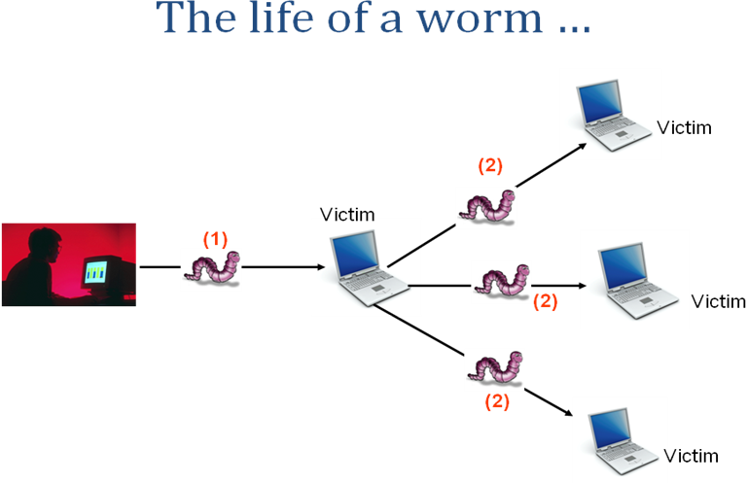
The Life Cycle of a Simple Worm:
- Scanning for a victim
- Exploiting the victim
- Cloning itself onto the victim
- Running the clone to further spread infection
- Stealth techniques used to hide itself
Scanning for a victim:
- Random scan – random IP
- Selective random scan – IP from global and local routing addresses
- Full scan – scan all IP addresses
- Divide and conquer scan – divide IP addresses among child worms
- Subnet scan – detect and scan local subnet
- Etc etc
Exploiting the victim:
- What is an exploit? – simply put: a piece of code which provides “access” to a victim computer by utilizing some flaw in the logic of a program running on the victim computer
- By “access” I mean the ability to run commands/programs on the remote computer.
- Network worms use what is called a “remote exploit” – an exploit which can be launched remotely and which gives some code running privileges on the victim
- Find a suitable exploit to use in the worm
- Understand the exploit
- Black box approach (wrapper around the exploit)
- White box approach (modifying the exploit)

Cloning itself onto the victim:
- Once the victim has been exploited the worm needs to get a copy of itself on the victim
- Tftp?? Blaster worm
- Http server ??
- Ftp server ??
- Compile source??
- Include worm in the shellcode??
Running the clone to further spread infection:
- Once the clone has been downloaded run it
- Make it a service??
- Add a registry entry for startup??
- …
- Clone starts scanning again
- Clone finds a victim
Cycle continues …
Stealth techniques used to hide itself:
- Hide process
- Hide files
- Hide activity
- Delete logs
- …rootkit…??
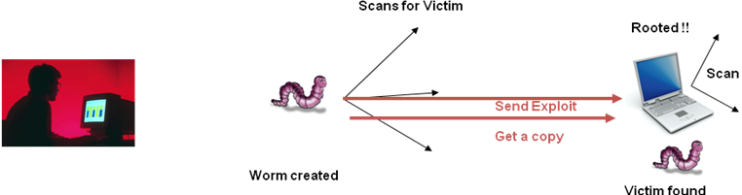

Some worm detection tools used:
Avira AntiVir Removal Tool for Windows 3.0.1.16:Avira AntiVir Removal Tool detects and eliminates Worm/Sober.J, Worm/Sober.P, Worm/Sober.Y and Worm/Stanit.A worms

W32/Sober Worm and its variants removal 3.0:W32/Sober Worm and its variants removal - removal tool will detect and remove W32/Sober Worm and its variants

Klez Removal Tool 1.0.11:Klez Removal Tool - removal for Klez worm

I-Worm.Zafi.b removal tool 12.0.0.0:I-Worm.Zafi.b removal tool- removal tool for I-Worm.Zafi.b and I-Worm.Bagle.at,au
Microsoft Blaster Worm Removal Tool for Win2k/XP:Microsoft Blaster Worm Removal Tool is a removal tool for the MSBlast worm

W32.Blaster.Worm Removal Tool 1.0.6.1:Removal tool to clean the W32.Blaster.Worm infections (fix the RPC vulnerability)

W32.Welchia.Worm Removal Tool 1.06:W32.Welchia.Worm Removal Tool .
AVIRA Removal Tool for Windows 3.0.1.16:Avira AntiVir Removal Tool detects and eliminates Worm/Sober.J, Worm/Sober.P, Worm/Sober.Y and Worm/Stanit.A worms

Blaster Worm Removal Tool 1.0.6.1:Removal tool to clean the W32.Blaster.Worm infections

3.2 Existing System:

- In previous simulation model uses a combination of the deterministic epidemic model and a general stochastic epidemic model to model the effect of large-scale worm attacks.
- In an Existing system the complexity of the general stochastic epidemic model makes it difficult to derive insightful results that could be used to contain the worm.
- In a previous study it is used to detect the presence of a worm by detecting the trend, not the rate, of the observed illegitimate scan traffic.
- The filter is used to separate worm traffic from background non worm scan traffic.

Drawbacks of Existing System:
- Very complex.
- By the time the worm is recognized it leads to lot of damage because of the fastness of worm propagation.

For example, consider the Code Red worm Version 2 that exploited a buffer overflow vulnerability in the Microsoft IIS Web servers. It was released on19 July 2001 and over a period of less than 14 hours infected more than 359,000 machines.

3.3 Proposed System:

- This model leads to the development of an automatic worm containment strategy that prevents the spread of a worm beyond its early stage.
- Specifically, for uniform scanning worms, we are able to
  - Provide a precise condition that determines whether the worm spread will eventually stop.
  - Obtain the distribution of the total number of hosts that the worm infects.
- We obtain the probability that the total number of hosts that the worm infects is below a certain level, as a function of the scan limit.
- Our strategy can effectively contain both fast scan worms and slow scan worms without knowing the worm signature in advance or needing to explicitly detect the worm.
- We restrict the total number of scans per host to the dark-address space.

Advantages of Proposed System:
- Early containment helps in saving lots of damage.
- It can effectively contain both fast scan worms and slow scan worms without knowing the worm signature in advance or needing to explicitly detect the worm.
- we also obtain the probability that the total number of hosts that the worm infects is below a certain level, as a function of the scan limit.
- Using the branching process model, we are able to provide a precise bound on the total number of scans that ensure that the worm will eventually die out.
3.4 PURPOSE

In this project we are going model a worm and show the propagation of worms. Then we design a containment which is automated and it is used to contain the spreading of worms beyond its early stages. Thus this project can be used understand the worm propagation. This can be useful to design an Antivirus technique to contain worms. Thus our project can be used in the domain of Network Security.

- SOFTWARE REQUIREMENT SPECIFICAION

4.1 SPECIPICATION PRINCIPLES:
Software Requirements Specification plays an important role in creating quality software solutions. Specification is basically a representation process. Requirements are represented in a manner that ultimately leads to successful software implementation.
Requirements may be specified in a variety of ways. However there are some guidelines worth following: -
- Representation format and content should be relevant to the problem
- Information contained within the specification should be nested
- Diagrams and other notational forms should be restricted in number and consistent in use.
- Representations should be revisable.

Software Requirements Specifications:
The software requirements specification is produced at the culmination of the analysis task. The function and performance allocated to the software as a part of system engineering are refined by establishing a complete information description, a detailed functional and behavioral description, and indication of performance requirements and design constraints, appropriate validation criteria and other data pertinent to requirements.

4.2 FEASIBILITY STUDY:
All projects are feasible given unlimited resources and infinite time. But the development of software is plagued by the scarcity of resources and difficult delivery rates. It is both necessary and prudent to evaluate the feasibility of a project at the earliest possible time.
Three key considerations are involved in the feasibility analysis.
Economic Feasibility:
This procedure is to determine the benefits and savings that are expected from a candidate system and compare them with costs. If benefits outweigh costs, then the decision is made to design and implement the system. Otherwise, further justification or alterations in proposed system will have to be made if it is to have a chance of being approved. This is an ongoing effort that improves in accuracy at each phase of the system life cycle.
Technical Feasibility:
Technical feasibility centers on the existing computer system (hardware, software, etc.,) and to what extent it can support the proposed addition. If the budget is a serious constraint, then the project is judged not feasible.
Operational Feasibility:
People are inherently resistant to change, and computers have been known to facilitate change. It is understandable that the introduction of a candidate system requires special effort to educate, sell, and train the staff on new ways of conducting business.

Feasibility Study in this Project:
1. Technical feasibility:
The system is self-explanatory and does not need any extra sophisticated training. As the system has been built by concentrating on the Graphical User Interface Concepts, the application can also be handled very easily with a novice User. The overall time that is required to train the users upon the system is less than half an hour.
The System has been added with features of menu-driven and button interaction methods, which makes the user the master as he starts working through the environment. The net time the customer should concentrate is on the installation time.

2. Financial Feasibility:
i)Time Based: Contrast to the manual system management can generate any report just by single click. In manual system it is too difficult to maintain historical data which become easier in this system. Time consumed to add new records or to view the reports is very less compared to manual system. So this project is feasible in this point of view
ii) Cost Based: No special investment need to manage the tool. No specific training is required for employees to use the tool. Investment requires only once at the time of installation. The software used in this project is freeware so the cost of developing the tool is minimal and hence the overall cost.
4.3 System Requirements:
Software:
FRONT END : JAVA, SWING
OPERATING SYSTEM : WINDOWS XP

Hardware:

PROCESSOR : PENTIUM IV 2.6 GHz
RAM : 512 MB
HARD DISK : 20 GB

- SOFTWARE DESIGN

5.1 Introduction:

Design is the first step in the development phase for any technique and principles for the purpose of defining a device, a process or system in sufficient detail to permit its physical realization.

Once the software requirements have been analyzed and specified the software design involves three technical activities design, coding, generation and testing that are required to build and verify the software.

The design activities are of main importance in this phase, because in this activity, decisions ultimately affecting the success of the software implementation and its ease of maintenance are made. These decisions have the final bearing upon reliability and maintainability of the system.

Design is the only way to accurately translate the customer’s requirements into finished software or a system.

Design is the place where quality is fostered in development. Software design is a process through which requirements are translated into a representation of software. Software design is conducted in two steps. Preliminary design is concerned with the transformation of requirements into data.

5.2 SYSTEM ARCHITECTURE:

Modeling and Automated Containment of Worms
Worm Model
Containment On
Automatic Worm Scanning
Manual Worm Scanning
Containment OFF
Starting Propagation
Stopping Propagation
Containment
5.3 DATA FLOW DIAGRAMS:

The data flow diagram is one of the most improvement tools used by the system analyst DeMacro(1978) and Gane Sarson(1979) popularized the use if the data flow diagram as modeling tools through their structured system analysis methodologies.

Data flow diagram illustrates how the data is processed by a system in terms of inputs and outputs. A data flow diagram should be the first tool used by system analyst to model system components.These components are the system processes ,the data used by these processes and external entities that interact with the system and the information flow in the system.

Data flow diagram will act as a graphical representation of the system in terms of interaction between the system, external entities, and process and how data stored in certain location.

There are 4 kinds of system components.
- External entities
- Data stores
- Process
- Data Flow

External Entity:
External entities are the objects outside the system, with which the system communicates. These are the sources and destinations of the system`s input and outputs.

Data Store:
Data stores are repositories in the System. They are some times also referred to as files.

Process:
A process transforms incoming data flow into out going data flow.The name and number appear inside the circle that represents the process in a data flow diagram.

Data Flow:
Data flows are pipelines through which packets of information flow. Label the arrows with the name of the data that moves through it.

Data Flow

Source or Destination

Data Store

Processing Node

Data Flow Diagram
Host 1
Host 2
Host 3
Host 4
Worm Spreading
Worm Scanner
Containment
Worm Scanner
Containment
Worm Scanner
Containment
Worm Scanner
Containment

5.4 UML DIAGRAMS:

INTRODUCTION

UML is a notation that resulted from the unification of Object Modeling Technique and Object Oriented Software Technology .UML has been designed for broad range of application. Hence, it provides constructs for a broad range of systems and activities.

An Overview of UML in five notations

- Use case diagrams

Use cases are used during requirements elicitation and analysis to represent the functionality of the system. Use cases focus on the behavior of the system from the external point of view. The actor is outside the boundary of the system, whereas the use cases are inside the boundary of the system.

- Class diagrams
Class diagrams to describe the structure of the system. Classes Are abstraction that specify the common structure and behavior of a set Class diagrams describe the system in terms of objects, classes, attributes, operations and their associations.

- Sequence diagrams
Sequence diagrams are used to formalize the behavior of the system and to visualize the communication among objects. They are useful for identifying additional objects that participate in the use cases. A Sequence diagram represents the interaction that take place among these objects.

4. Statechart diagrams
State chart diagrams describe the behavior of an individual object as a number of states and transitions between these states. A state represents a particular set of values for an object. The sequence diagram focuses on the messages exchanged between objects, the state chart diagrams focuses on the transition between states.

5. Activity diagrams
An activity diagram describes a system in terms of activities. Activities are states that represents the execution of a set of operations. Activity diagrams are similar to flowchart diagram and data flow.

Use Case Diagram
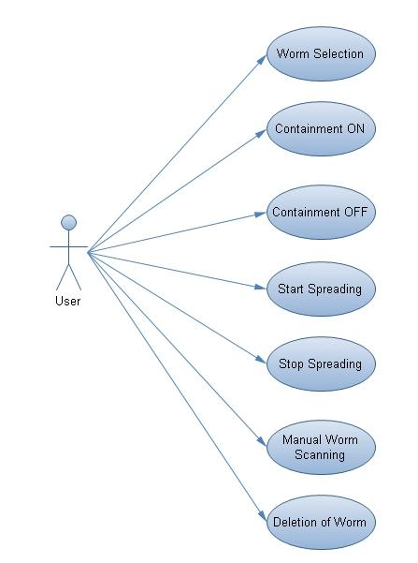

USECASE SPECIFICATION FOR THE USECASE DESIGN REPORTS:
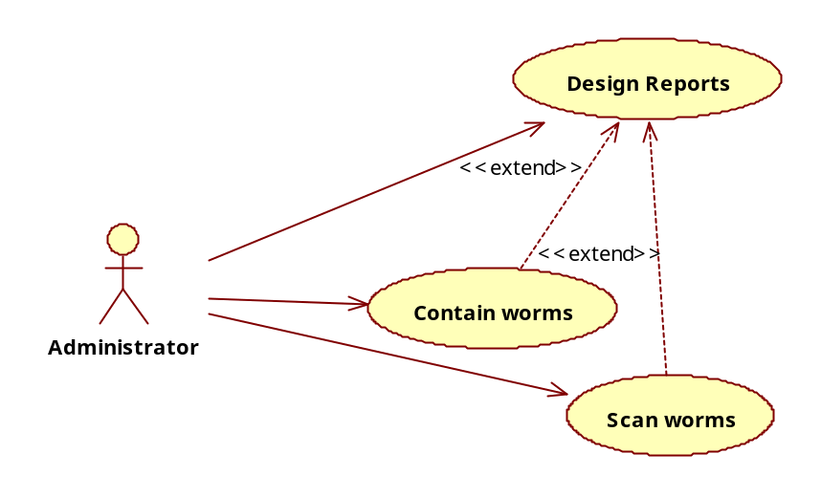
Name: Design Reports

Participating Actors: Administrator

Description: This usecase is meant for designing the UserInterface and reports.

Main flow :
- In this we design the user interface for all the hosts.
- We design the user interface in a graphical manner or GUI. By showing the output in GUI gives more attractive and understandable to everyone.
- we design the containment window to show the scanning, detection of worms.
- Report generation is also been done in this usecase only.

.Post Condition: If the above steps are successfully completed, user Interface is designed.

USECASE SPECIFICATION FOR THE USECASE SCAN WORMS:

Name: Scan worms

Participating Actors: Administrator

Description: this usecase is meant for Scanning, detecting and categorizing the worms

Main flow :
- Scanning of worms is done to know whether worm is present.
- Detects the worms.
- Categorize the worms whether they are uniform scanning worms or preference scanning worms.
- If worm is present it deletes the worm.

Post Condition: If the above steps are successfully completed worms are been deleted.

USECASE SPECIFICATION FOR THE USECASE CONTAIN WORMS:

Name : Contain worms

Participating Actors: Administrator

Description: This usecase is meant for automatic containment of worms.

Main flow:
- preventing the spread of worm at the early stage is done.
- Automatic worm stoppage is to be done.
- Manual containment of worms if it is not stopped at early stage , is to be done.

Post Condition: If the above steps are successfully completed the worm is contained and the status information is displayed in confirmation.

Class Diagram
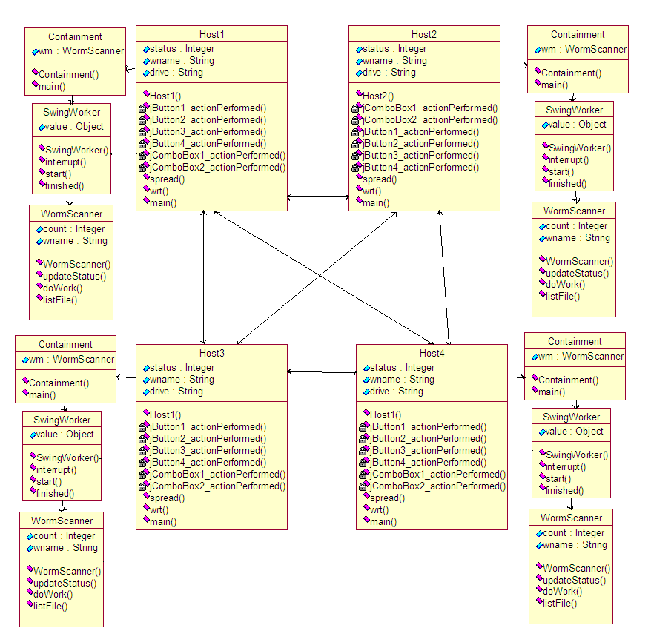

State Diagram
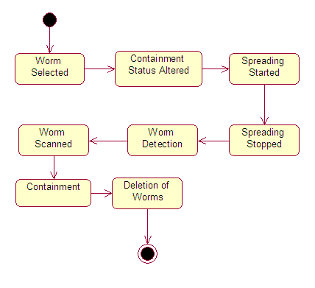

Activity Diagram

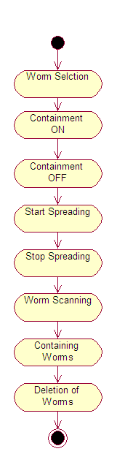

Sequence Diagram

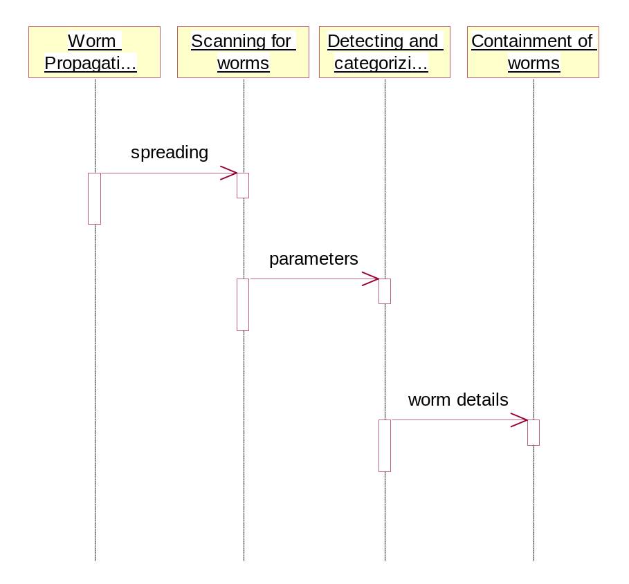

Collaboration Diagram

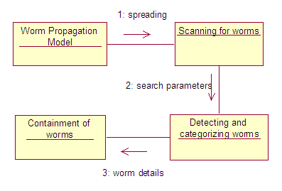

Component Diagram

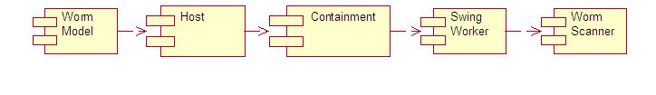

6. CODING AND IMPLEMENTATION

6.1 Modules of the Project

- User Interface Design
- Worm Propagation Model
- Scanning for worms
- Detecting and categorizing worms
- Containment of worms

Module Description
User Interface Design
In this module we have designed the user interface for all the hosts. We design the user interface to show our propagation of worms in a graphical manner or GUI. By showing the output in GUI gives more attractive and understandable to everyone. Then we design the containment window to show the scanning, detection of worms. Thus we design the whole user interface in this module.

Worm Propagation Model
In this module, we create a worm spreading model. This model is designed for the propagation of worms inside a network. Inside the network we spread the worms in a controlled environment. To create worm propagation model we need to form a network by using the server socket class and socket class available in Java. These two classes are used to create a connection to transfer data from a host to other host inside a network.
Scanning for worms
Our strategy is based on limiting the number of scans to dark-address space. The limiting value is determined by our analysis. Our automatic worm containment schemes effectively contain both uniform scanning worms and local preference scanning worms, and it is validated through simulations and real trace data to be non-intrusive.

Detecting and categorizing worms
The model is developed for uniform scanning worms and then extended to preference scanning worms. We detect these two worms and categorize it in this module.

Containment of worms
This model leads to the development of an automatic worm containment strategy that prevents the spread of a worm beyond its early stage. Specifically, for uniform scanning worms, we are able to 1) provide a precise condition that determines whether the worm spread will eventually stop and 2) obtain the distribution of the total number of hosts that the worm infects.

6.2 Features of Software:

JAVA:
Java is a high-level programming language which consists of the following features:
• Simple | • Architecture-neutral
• Object-oriented | • Portable
• Distributed | • High-performance
• Interpreted | • Multithreaded
• Robust | • Dynamic
• Secure
Each Java program is both compiled and interpreted. With a compiler, you translate a Java program into an intermediate language called Java bytecodes--the platform-independent codes interpreted by the Java interpreter. With an interpreter, each Java bytecode instruction is parsed and run on the computer. Compilation happens just once; interpretation occurs each time the program is executed. This figure
illustrates how this works. 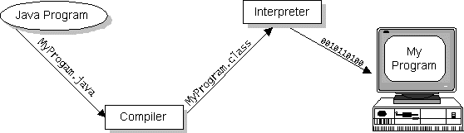
Java Compilation
You can think of Java bytecodes as the machine code instructions for the Java Virtual Machine (Java VM). Every Java interpreter, whether it's a Java development tool or a Web browser that can run Java applets, is an implementation of the Java VM. The Java VM can also be implemented in hardware.
Java bytecodes help make "write once, run anywhere" possible. You can compile your Java program into bytecodes on any platform that has a Java compiler. The bytecodes can then be run on any implementation of the Java VM. For example, the same Java program can run on Windows NT, Solaris, and Macintosh.

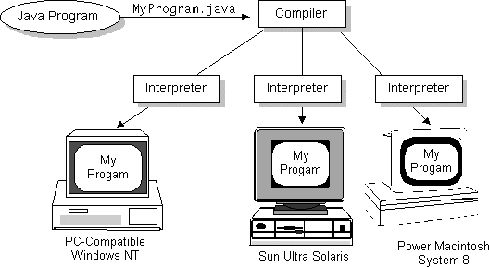

The Java Platform:
A platform is the hardware or software environment in which a program runs. The Java platform differs from most other platforms in that it's a software-only platform that runs on top of other, hardware-based platforms. Most other platforms are described as a combination of hardware and operating system.
The Java platform has two components:
- The Java Virtual Machine (Java VM)
- The Java Application Programming Interface (Java API)
SWING:
The Swing toolkit includes a rich set of components for building GUIs and adding interactivity to Java applications. Swing includes all the components you would expect from a modern toolkit: table controls, list controls, tree controls, buttons, and labels. Swing is far from a simple component toolkit, however. It includes rich undo support, a highly customizable text package, integrated internationalization and accessibility support. To truly leverage the cross-platform capabilities of the Java platform, Swing supports numerous look and feels, including the ability to create your own look and feel. The ability to create a custom look and feel is made easier with Synth, a look and feel specifically designed to be customized. Swing wouldn't be a component toolkit without the basic user interface primitives such as drag and drop, event handling, customizable painting, and window management.
Swing is part of the Java Foundation Classes (JFC). The JFC also include other features important to a GUI program, such as the ability to add rich graphics functionality and the ability to create a program that can work in different languages and by users with different input devices.
The Swing toolkit includes a rich array of components: from basic components, such as buttons and check boxes, to rich and complex components, such as tables and text. Even deceptively simple components, such as text fields, offer sophisticated functionality, such as formatted text input or password field behavior. There are file browsers and dialogs to suit most needs, and if not, customization is possible. If none of Swing's provided components are exactly what you need, you can leverage the basic Swing component functionality to create your own.

7. SCREEN

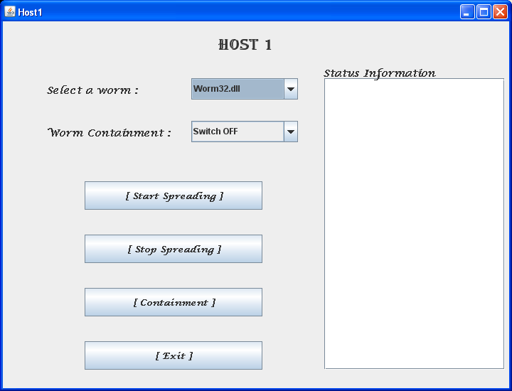

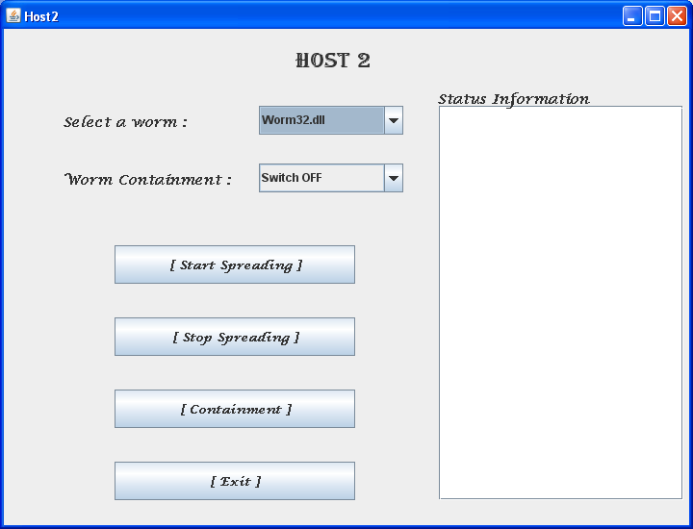
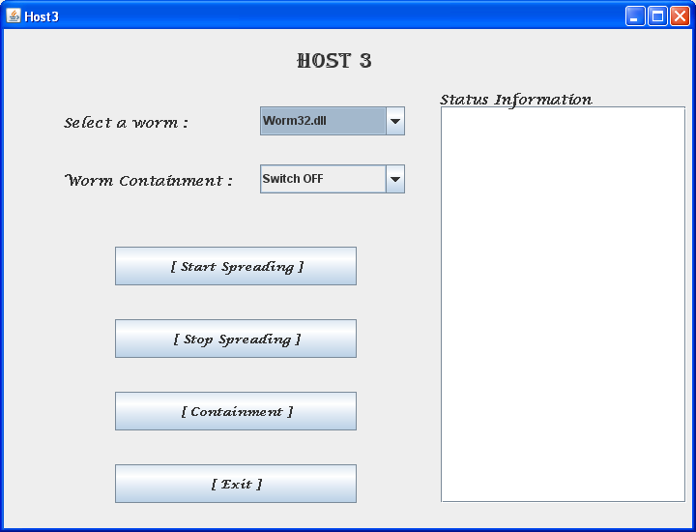

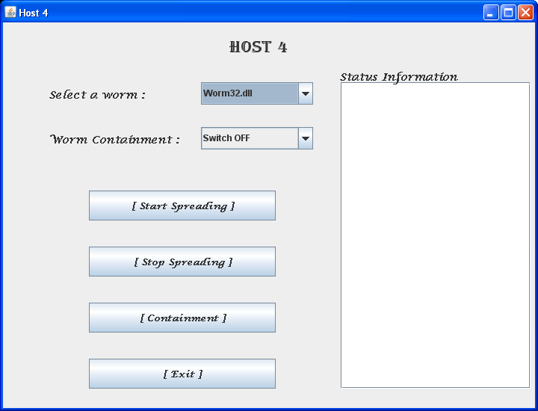
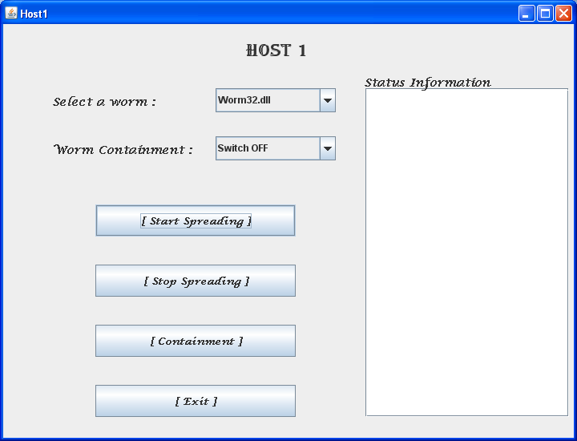

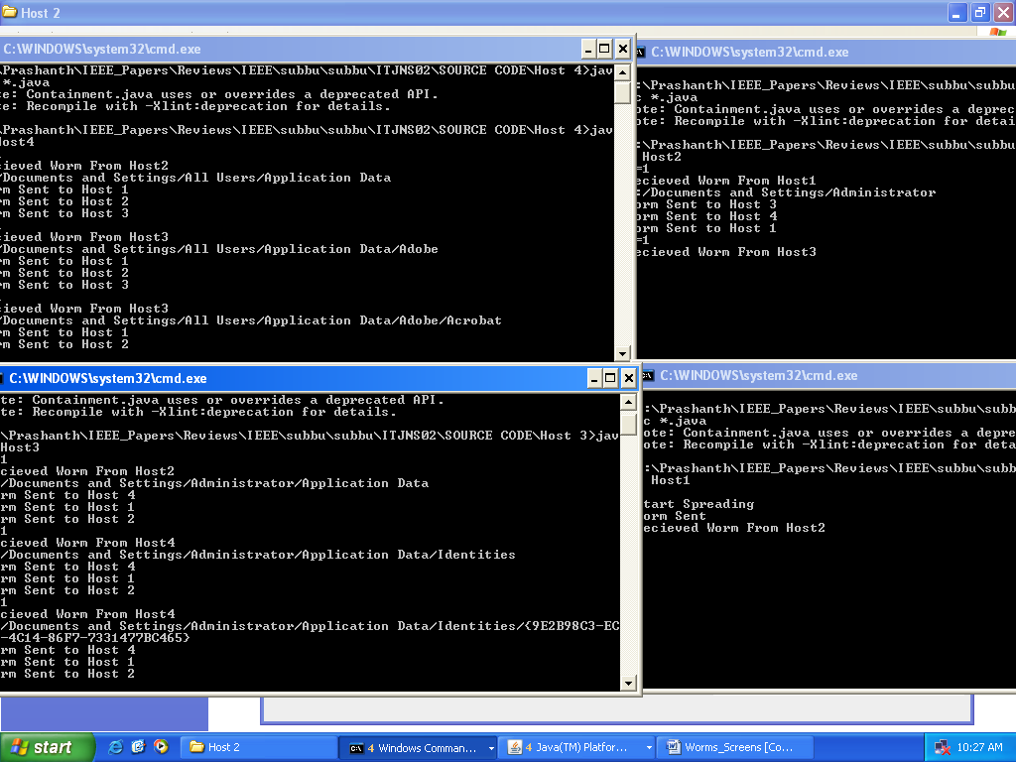

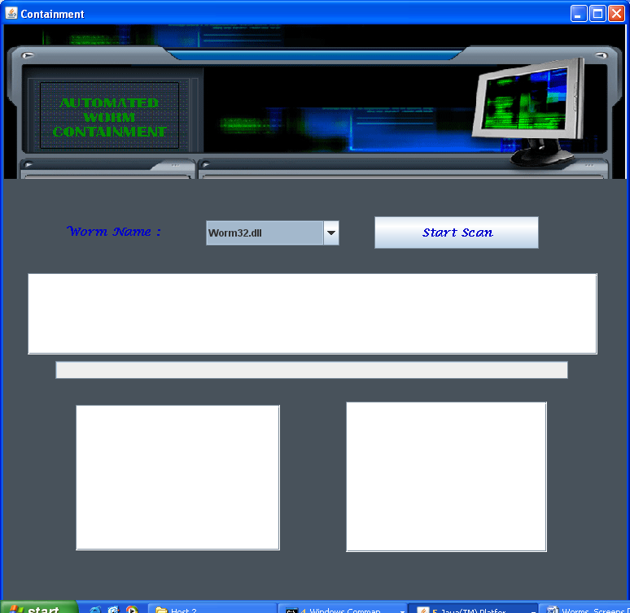

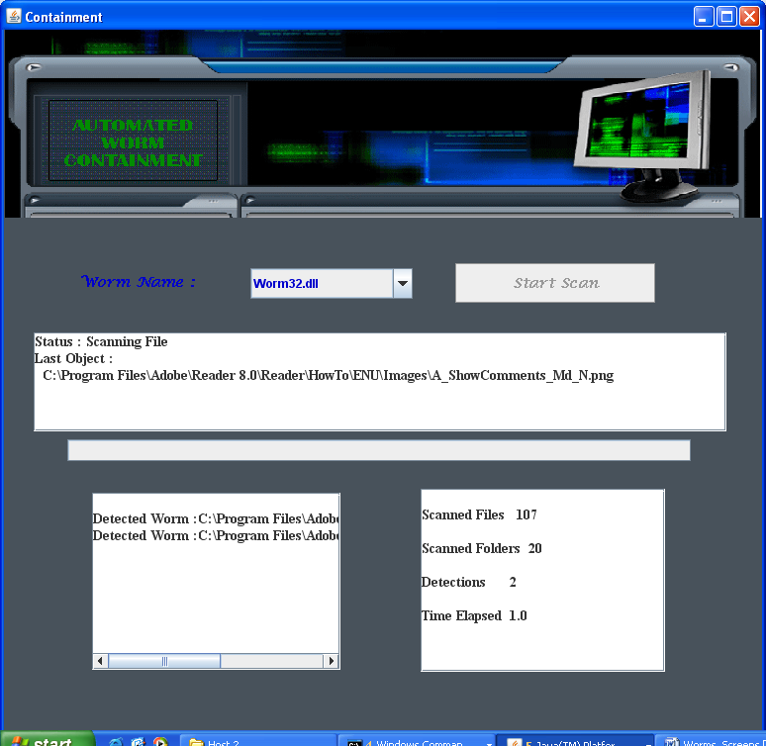
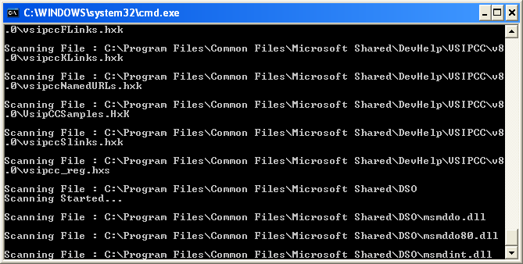

- TESTING

TESTING

Software Testing is a critical element of software quality assurance and represents the ultimate review of specification, design and coding, Testing presents an interesting anomaly for the software engineer.

Testing Objectives include:

- Testing is a process of executing a program with the intent of finding an error
- A good test case is one that has a probability of finding an as yet undiscovered error
- A successful test is one that uncovers an undiscovered error

Testing Principles:

- All tests should be traceable to end user requirements
- Tests should be planned long before testing begins
- Testing should begin on a small scale and progress towards testing in large
- Exhaustive testing is not possible
- To be most effective testing should be conducted by a independent third party

Test cases:

Test  C.No. | Input | Expected Behavior | Observed  behavior | Status  P = Passed  F = Failed
1 | To spread worms | Select a worm from the list and click on start spreading. | -do- | P
2 | To stop the worm spreading | Click on stop spreading. | -do- | P
3 | Spreading worms with no folder in a drive | If there is no folder in the drive then the application will display null for worms spreading. | -do- | P
4 | To delete worms from the hard disk | Click on Containment button in application. | -do- | P

- CONCLUSION

CONCLUSION

In this paper, we have studied the problem of combating Internet worms. To that end, we have developed a branching process model to characterize the propagation of Internet worms. Unlike deterministic epidemic models studied in the literature, this model allows us to characterize the early phase of worm propagation. Using the branching process model, we are able to provide a precise bound M on the total number of scans that ensure that the worm will eventually die out. Further, from our model, we also obtain the probability that the total number of hosts that the worm infects is below a certain level, as a function of the scan limit. The insights gained from analyzing this model also allow us to develop an effective and automatic worm containment strategy that does not let the worm propagate beyond the early stages of infection. Our strategy can effectively contain both fast scan worms and slow scan worms without knowing the worm signature in advance or needing to explicitly detect the worm. We show via simulations and real trace data that the containment strategy is both effective and non-intrusive.

- SCOPE FOR FUTURE ENHANCEMENT

For further work, we would like to propose a statistical model for the spread of topology-aware worms and subsequently design mechanisms for automatic containment of such worms. We would also like to characterize the deviation of our proposed branching process model from the “ideal” stochastic epidemic model, assuming that the values of its rich set of parameters were available. Finally, we would like to port our worm containment schemes to edge routers and local routers and to evaluate the performance using real data from enterprise networks.

We extended the worm containment scheme to local preference scanning worms. In this scheme, we restrict the total number of scans per host to the dark-address space. We derive the precise bound N on the total number of scans to the dark-address space, which ensures that the worm will be contained. This containment scheme, combined with firewalls at the network boundary, allows for incremental deployment of the worm containment system without participation of outside networks.

11. BIBLIOGRAPHY

References

[1]CAIDA,“CAIDAAnalysis of Code-Red,” http://www.caida.org/analysis/security/ code-red/, 2007.

[2] “The Cost of Code Red: $1.2 Billion,” USA Today News, http://www.usatoday. com/tech/news/2001-08-01-code-red-costs.htm, 2001.

[3] Cisco Documentation, “Configuring Port Security,” http://www. cisco.com/univercd/cc/td/doc/product/lan/cat6000/12_1e/swconfig/port_sec.htm, 2007.

[4] H. Andersson and T. Britton, “Stochastic Epidemic Models and Their Statistical Analysis,” Lecture Notes in Statistics, vol. 151, 2000.

[5] J. Bartiomiejczyk and M. Phipps, Preventing Layer 2 Security Threats, http://searchnetworking.techtarget.com/tip/0,289483,sid7_gci1009100,00.html, 2007.

